**What is Cloud Computing?**

* It is the use of remote servers on the internet to store, manage and process data rather than a local server or personal computer.

**Application+platform+infrastructure – cloud computing**

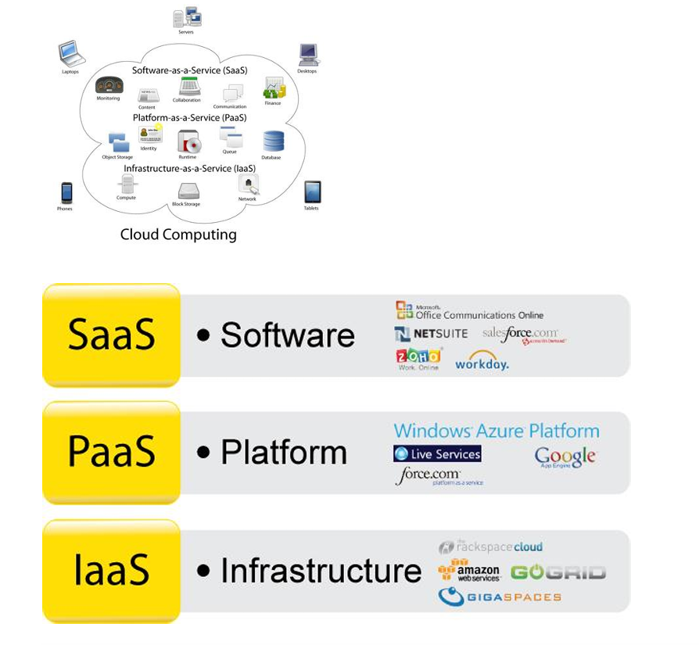

**Cloud models:**

* **IAAS – Infrastructure as a service (only infrastructure without os) – System admins**
* **PAAS – Platform as a service (with os) - Developers**
* **SAAS – Software as a service – End user**

**Types of cloud:**

* **Public cloud**
* **Private cloud**
* **Hybrid cloud**

Hybrid cloud act as a bridge between public and private cloud to communicate.

**Benefits of Cloud Based Computing**

1. No upfront expenses for creating servers

2. No expense for maintaining servers

3. Benefit from massive economies of scale

4. Increase speed and agility

5. Go global in minutes